Save as Web Page
Presentations can be saved by selecting File|Save from the menu bar. However, if you want to post Power Point presentations on the Internet, you may want to save them as web pages so students and other visitors to your web site can view the presentation even if they do not have Power Point installed on their computers. Select File|Save As Web Page from the menu bar. Choose your web page directory on the network from the Look in: drop-down menu and name the file in the File name: box. Click Save to save the presentation in web format.
Page Setup
Select File|Page Setup from the menu bar to access options for printing the presentation slides. Select the format the printed slides will be used for from the Slides sized for drop-down menu or enter a specific print size using the Width and Height boxes. Select the page orientation for the slides and for other print material from the presentation in the Orientation section.
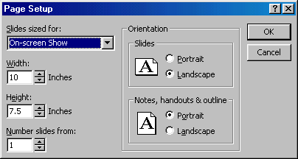

Print
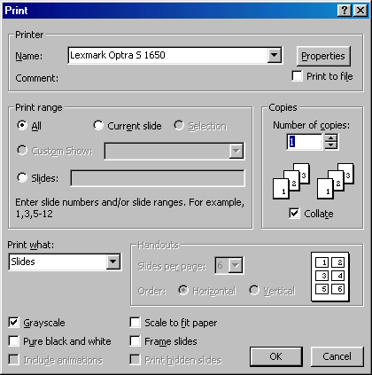
Select File|Print from the menu bar to print the presentation.

Print range - Select All to print all the slides in the presentation, Current slide to print only the current slide, or enter slide numbers in the Slides field to print only certain slides.
Copies - Enter the number of copies of each slide specified in Print range and check the Collate box if necessary.
Print What -
- Slides prints a full-page slide on each page.
- Handouts prints as many slides as you designate on each page.
- Notes Page prints one slide with that slide's notes on each page
- Outline view prints the outline of the presentation
Click OK to print.

